**2016-2017 Señorita Schleicher-Aula 213**

Español III

Email: [aschleicher@oxford.k12.pa.us](mailto:aschleicher@oxford.k12.pa.us)

Website: <http://www.schleicher.weebly.com>



**CLASSROOM RULES AND PROCEDURES**

*Your success in learning another language assumes that you will be an active participant in class. This is an interactive experience! There are reasonable expectations of all students. A language cannot be learned by passively absorbing it!! You have to be an active listener/speaker. If you “get into it,” your experience in language-learning will be much more successful. Practice it! Speak it! Laugh at yourselves! Try it! IT’S FUN!*

**CLASSROOM EXPECTATIONS**

**I. CLASS RULES: *REGLAS DE LA CLASE:***

A. **RESPECT** your teacher, classmates, classroom and yourself.

B**. BE PREPARED** when you come to class. Bring a pencil/pen, notebooks **AND YOUR iPAD FULLY CHARGED**.

C. **BE ON TIME** and sit in your assigned seat. You have plenty of time to pass between classes AND use the bathroom in between. Students arriving after the bell has rung will need an agenda signed from the office or a teacher. Attendance will be taken in the first few minutes of class. Coming late to class repeatedly (3 times) will result in a detention and/or referral to the office/parent. If tardiness continues after a detention, a referral will be made to the office. *Be warned- I love giving 7:00 am detentions!*

D. ¡**NO COMIDA o BEBIDAS!** ¡No estamos en la cafetería!

E. **FOLLOW DIRECTIONS** the first time they are given and work only on what is assigned to you in this class. Other work may be taken.

F. **BE RESPONSIBLE** for everything you do and for your possessions.

G.**CELL PHONES** should be turned off and invisible during the class period.  If I see or hear your phone it will be taken away and given to an administrator, according to cell phone policy outlined in the OAHS handbook.  Refusal to turn over the cell phone will be treated as insubordinate behavior.

H. **iPads MAY ONLY BE OUT WHEN YOU ARE GIVEN PERMISSION**. Remember that the iPad is a resource and it belongs to the school. Be respectful. Failure to obtain permission or abuse of the iPad (i.e. playing games, air dropping, messaging, taking pictures of others without their consent, etc.) will result in confiscation of your iPad or an office referral.

I. **ALL SCHOOL RULES/HANDBOOK RULES APPLY TO THIS CLASS!**

**II. CLASS PROCEDURES: *PROCEDIMIENTOS DE LA CLASE:***

A. **ABSENCES**:

* If you are absent for any reason and you missed a test/quiz, you will take that test/quiz upon your return. You must arrange a time with me. **I will not come looking for you**. *You are responsible for finding out what you missed.* PLEASE CHECK THE MISSED WORK BINS BEFORE YOU SEE ME. If you have any questions about the work in the bins, please don’t hesitate to ask!
* **Homework** that was due on the day(s) you were absent: You must *give it to me for credit the day you return*.
* **Proyectos/Tarea Mensual**: For each day that a project or assignment is late, you will lose **10 points per day.** Always print out your own assignment (please don’t email it to me). **It is not my responsibility to do this.**

B. If a test/quiz is announced in advance and you miss the review day, you are still required to take the test/quiz on the scheduled day **(also applies to snow days)**.

C. You need to have a THREE RING BINDER for this class to organize all of your materials. Include a section for notes, hand-outs, and homework. Random notebook checks WILL occur. You may share your Spanish notebook with other courses.

D. SPANISH III: ALL SPANISH WILL BE SPOKEN in this classroom. A sincere effort on your part to listen carefully and use the language is required. Speaking Spanish in class (from the moment you walk in) is part of your participation grade. The more effort you make to speak it, the higher your participation grade will be! Make your mistakes loud enough for me to hear. “***Yo no sé*” is not an acceptable answer!** You are all in the same boat: TRY IT!

E. Lavatory use: You have PLENTY of time to use the bathrooms between classes. In an emergency, you may ask to go to the ***bathroom during the last five minutes of class*** and ONLY if you have your eHallpass filled out and ready to go. Please do not interrupt instruction unless it is an emergency. **Abuse of lavatory use will result in loss of your privilege.**

**III. ACADEMIC HONESTY: *LA HONESTIDAD ACADÉMICA***

**A. Cheating is not tolerated. This includes but is not limited to: copying homework, giving work to someone else to copy, projects, and copying on tests/quizzes.**

B. The use of on-line translators is only permitted as a dictionary (for a few words at most). You must use the Spanish that you learn in this class, not what the computer or a native Spanish speaker knows.

C. A violation of this academic honesty **will result in a zero** on the homework, project, quiz/test, etc. You will not be allowed to re-do the assignment.

**IV. GRADES: *LAS NOTAS/CALIFICACIONES:***

A. Marking period grades will be determined by the following percentages (per the Student Handbook)

* 70%- Performance Assessments (tests, quizzes, and skill-based performance measures)
* 20%- Formative Assessments (class work, in-class assignments, class participation, and other in-class measures)
* 10%- Homework

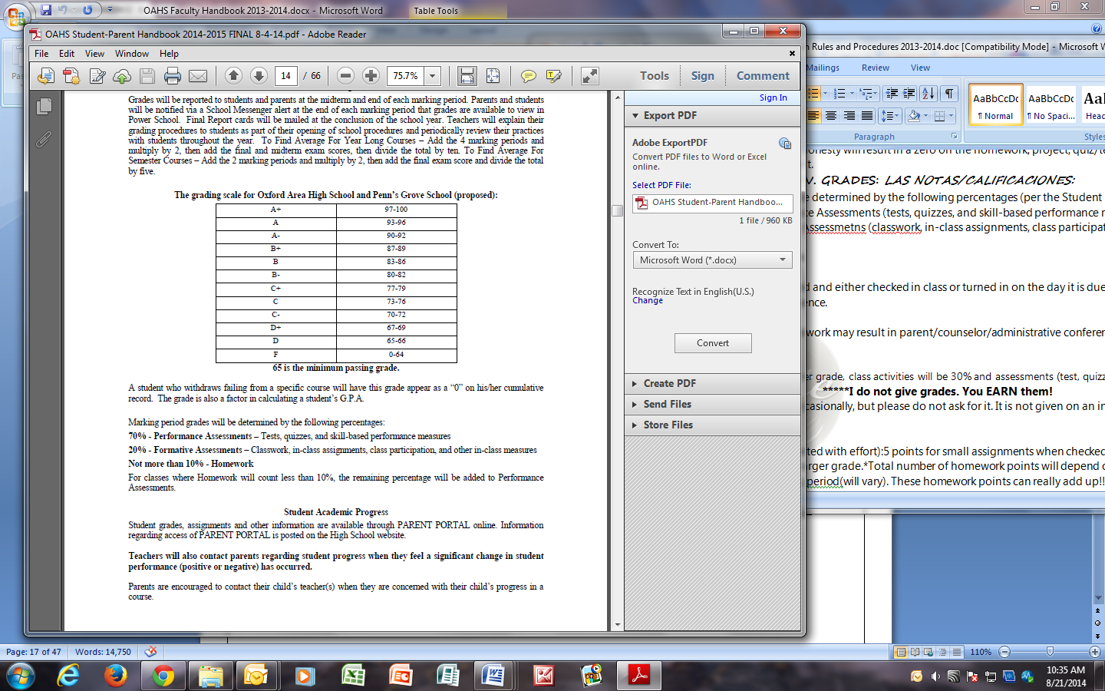B. Homework is to be completed and either checked in class or turned in on the day it is due. I will not take it late unless you had an excused absence.

C:\Documents and Settings\aschleicher\Local Settings\Temporary Internet Files\Content.IE5\MUN28YN8\MC900104846[1].wmfC. Grading Scales

D. Extra credit will be offered occasionally, **but please do not ask for it. It is not given on an individual basis** (it’s for everybody or nobody).

E. HOMEWORK GRADE (completed with effort):5 points for small assignments when checked. Larger assignments will be 10 points or collected for a larger grade.*Total number of homework points will depend on the number of assignments given per marking period (will vary). These homework points can really add up!!!

***The best way to earn the grade you want is to be attentive/on task in class, take notes when necessary, participate, do your assignments and in-class work, use your Spanish skills, be respectful and cooperative and prepare for tests/quizzes. Making an effort will make your grade what you want it to be!***

SYLLABUS and PHILOSOPHY FOR SPANISH III

*Spanish III is an elective course designed to provide a more advanced understanding of the Spanish language and its structure. Students will make use of skills learned in the first two years of language study to be able to communicate and comprehend spoken Spanish. These skills will be further developed and new skills acquired through advanced listening, speaking, reading and writing activities. Cultural awareness will be emphasized through various activities.*

**Course description and content of syllabus:**

**A. Objectives: Students will be able to:**

-describe past activities using regular and irregular verbs

-talk about what professions they would choose and why

-make suggestions, give warnings, command people

-describe the future, make predictions

-ask for assistance to make requests

-give simple directions

-describe how they are feeling

-maintaining a healthy lifestyle

**B. Other linguistic structures for this class include:**

-pronouns

-regular and irregular verbs in the preterite/imperfect and their uses

-pronouns with commands

-two pronoun sequencing

-vocabulary definitions in Spanish

-subjunctive

-imperfect vs. preterite

-future tenses

**C. Cultural elements:**

-traveling

-Hispanic holidays, festivals, and celebrations

-ordering foods

-Camino de Santiago

-la corrida de toros

-money and festivities

-history

****If during this class you need extra help, ***please*** come and see me to set up some tutoring time! Many questions and problems can be cleared up in just a few minutes before or after school, or I can find you a tutor!!

**Completa la próxima sección y entrégasela a la Srta. Schleicher mañana**

---------------------------------------------------------------------------------------------------------------------------------

Nombre (print) ___________________________________________________

Período____________

Fecha______________________

***¡Sí! I understand all of the rules and procedures and will honor them in this class.***

Firma______________________________________________________________

Firma de tu madre/padre/tutor/tutora ________________________________________________________________